**EXPERIMENT 7**

**Aim:** Design of registers and counters

**Exercise#1**: Design and verify 4-bit serial-in-serial-out (SISO) shift register shown in Figure-4 in structural style of architecture. Use reset control line to reset the register.

**Design Code (Flip Flop):**

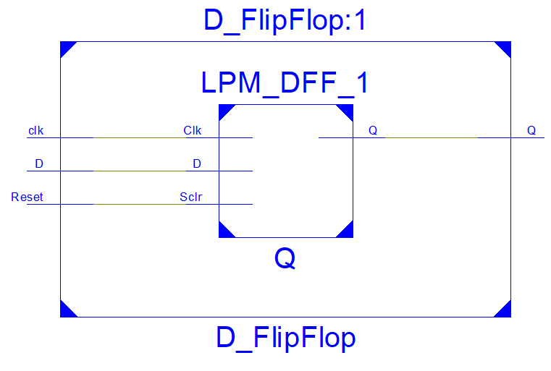library IEEE;

use IEEE.STD_LOGIC_1164.ALL;

entity D_FlipFlop is

Port ( D : in STD_LOGIC;

Reset : in STD_LOGIC;

clk : in STD_LOGIC;

Q : out STD_LOGIC);

end D_FlipFlop;

architecture Behavioral of D_FlipFlop is

begin

process(D, Reset, clk)

begin

if (clk'event and clk = '1') then

if(reset = '1' ) then

q <= '0';

else

q <= d;

end if;

end if;

end process;

end Behavioral;

**Design Code:**

library IEEE;

use IEEE.STD_LOGIC_1164.ALL;

entity Serial_in_serial_out is

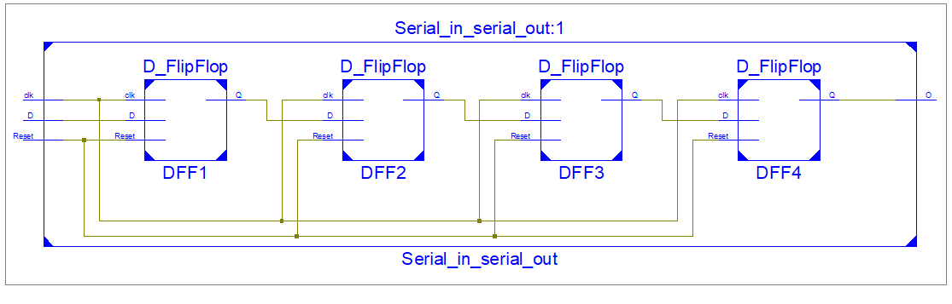 Port ( D : in STD_LOGIC;

Reset : in STD_LOGIC;

clk : in STD_LOGIC;

O : out STD_LOGIC);

end Serial_in_serial_out;

architecture Behavioral of Serial_in_serial_out is

component D_FlipFlop

Port ( D : in STD_LOGIC;

Reset : in STD_LOGIC;

clk : in STD_LOGIC;

Q : out STD_LOGIC);

end component D_FlipFlop;

signal S1, S2, S3 :STD_LOGIC;

begin

DFF1: D_FlipFlop port map(D, Reset, clk, S1);

DFF2: D_FlipFlop port map(S1, Reset, clk, S2);

DFF3: D_FlipFlop port map(S2, Reset, clk, S3);

DFF4: D_FlipFlop port map(S3, Reset, clk, O);

end Behavioral;

**Test Bench:**

D <= '0';

Reset <= '1';

wait for 100 ns;

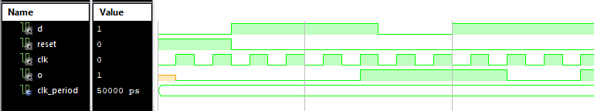D <= '1';

Reset <= '0';

wait for 100 ns;

D <= '1';

Reset <= '0';

wait for 100 ns;

D <= '0';

Reset <= '0';

wait for 100 ns;

D <= '1';

Reset <= '0';

wait for 100 ns;

wait for clk_period*10;

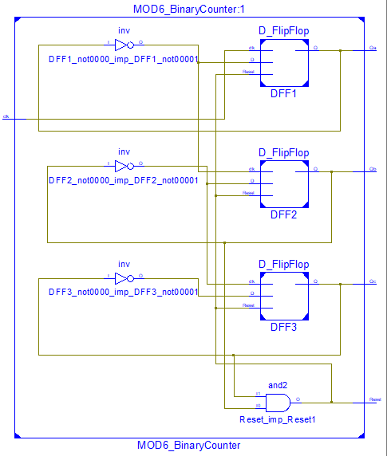**Exercise#2**: Design and verify MOD-6 binary counter shown in figure-5 using structural style of architecture.

**Design Code:**

library IEEE;

use IEEE.STD_LOGIC_1164.ALL;

entity MOD6_BinaryCounter is

Port (Reset : inout STD_LOGIC;

clk : in STD_LOGIC;

Qa,Qb,Qc : inout STD_LOGIC);

end MOD6_BinaryCounter;

architecture Behavioral of MOD6_BinaryCounter is

component D_FlipFlop

Port ( D : in STD_LOGIC;

Reset : in STD_LOGIC;

clk : in STD_LOGIC;

Q : out STD_LOGIC);

end component D_FlipFlop;

begin

Reset <= Qb and Qc;

DFF1: D_FlipFlop port map((not Qa), Reset, clk,Qa);

DFF2: D_FlipFlop port map((not Qb), Reset, (not Qa),Qb);

DFF3: D_FlipFlop port map((not Qc), Reset,(not Qb),Qc);

end Behavioral;

Test Bench:

Qa<='1';

Qb<='0';

Qc<='0';

Reset <='0';

wait for 100 ns;

Qa<='0';

Qb<='1';

Qc<='0';

Reset <='1';

wait for 100 ns;

Qa<='1';

Qb<='1';

Qc<='0';

Reset <='0';

wait for 100 ns;